**Acoustics and Audio Technology 4**

***Loudspeaker design assignment 2018***

With a partner your task is to design a loudspeaker system using two separate drivers – a woofer and a tweeter, the details of which are provided in the appendices overleaf.

In your teams of 2, each of you will be responsible for a different part of the loudspeaker design:

* **Team member 1** will work on the *physical design of the loudspeaker cabinet*.
* **Team member 2** will work on the *electronics and circuit design*.

So get into pairs and decide who will be responsible for which part.

The aim of this project is to combine your knowledge acquired from lectures with that from independent literature research to produce a convincing loudspeaker design.

Each team member will then produce a report (*no longer than 10 pages)* that includes their contribution to the finished design and discussion of the design process.

Remember, this is your design! Think of it as a home project where you would want to use your finished loudspeaker yourself, and design it as such.

However I would ask that you base your speaker cabinet design on a ported / bass reflex cabinet.

To start you off, here are some excellent sources of information:

1). <http://www.diysubwoofers.org/>

2). <http://en.wikipedia.org/wiki/Thiele/Small>

3). <http://sound.whsites.net/lr-passive.htm>

The assignment will contribute a total of **2*0%* towards your final grade in the AAT4 course** (so it will have a significant impact on your overall results!).

Please give it some serious attention.

Report submission

Please submit both an *electronic copy* and a *printed copy* of your report by the **5pm, Wednesday 11th April, 2018**.

The electronic copy should be submitted via the link on the Moodle site for the course. Copying and pasting of non-original content from other sources that is not properly referenced in the report is strictly prohibited. Your report will be checked automatically for plagiarism and when submitted to Moodle.

Please submit the printed copy of the report to the School teaching office in the James Watt South building.

Good luck!

Dr. D. Moran

Appendix A - TRUVOX 1225 (Woofer driver) parameters

**Specifications**

Nominal diameter (‘’) 12

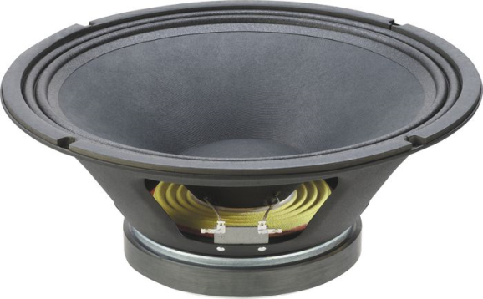Power rating (W) 250

X Max (mm) 2.35

f/pl (mm) 8

coil (mm) 12.7

Nominal impedance (O) 8

Sensitivity (dB) 97

Voice coil diameter (‘’) 2½

Surround Material Cloth - Sealed

Magnet type Ceramic

Magnet assembly flux (T) 1.2

Magnet weight (oz) 42

Chassis type Pressed Steel

Cone material Kevlar loaded paper



Thiele-Small parameters:

Frequency Range (Hz) 50-4000

Re (O) 5.13

Mmt (g) 46.5

D (m) 0.26

Qts 0.5

Vas (L) 55

Qms 6.7

Bl (Tm) 13.2

Qes 0.54

Cms (mm/N) 0.14

Fs (Hz) 63

Rms (kg/s) 2.76

Le (at 1kHz)0.84mH

Source - http://celestion.com/product/102/tf1225/

Appendix B - 811582 DT-80H Hifi dome tweeter (Tweeter driver) parameters

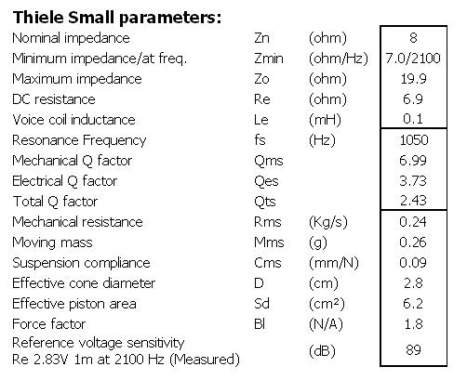

Frequency -3dB below resonance f3 (Hz) 715

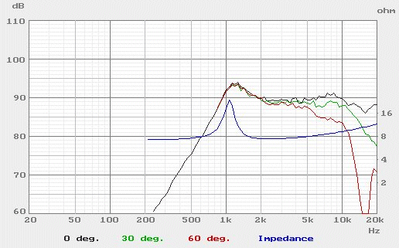

Source - http://www.europe-audio.com/Product.asp?Product_ID=3166